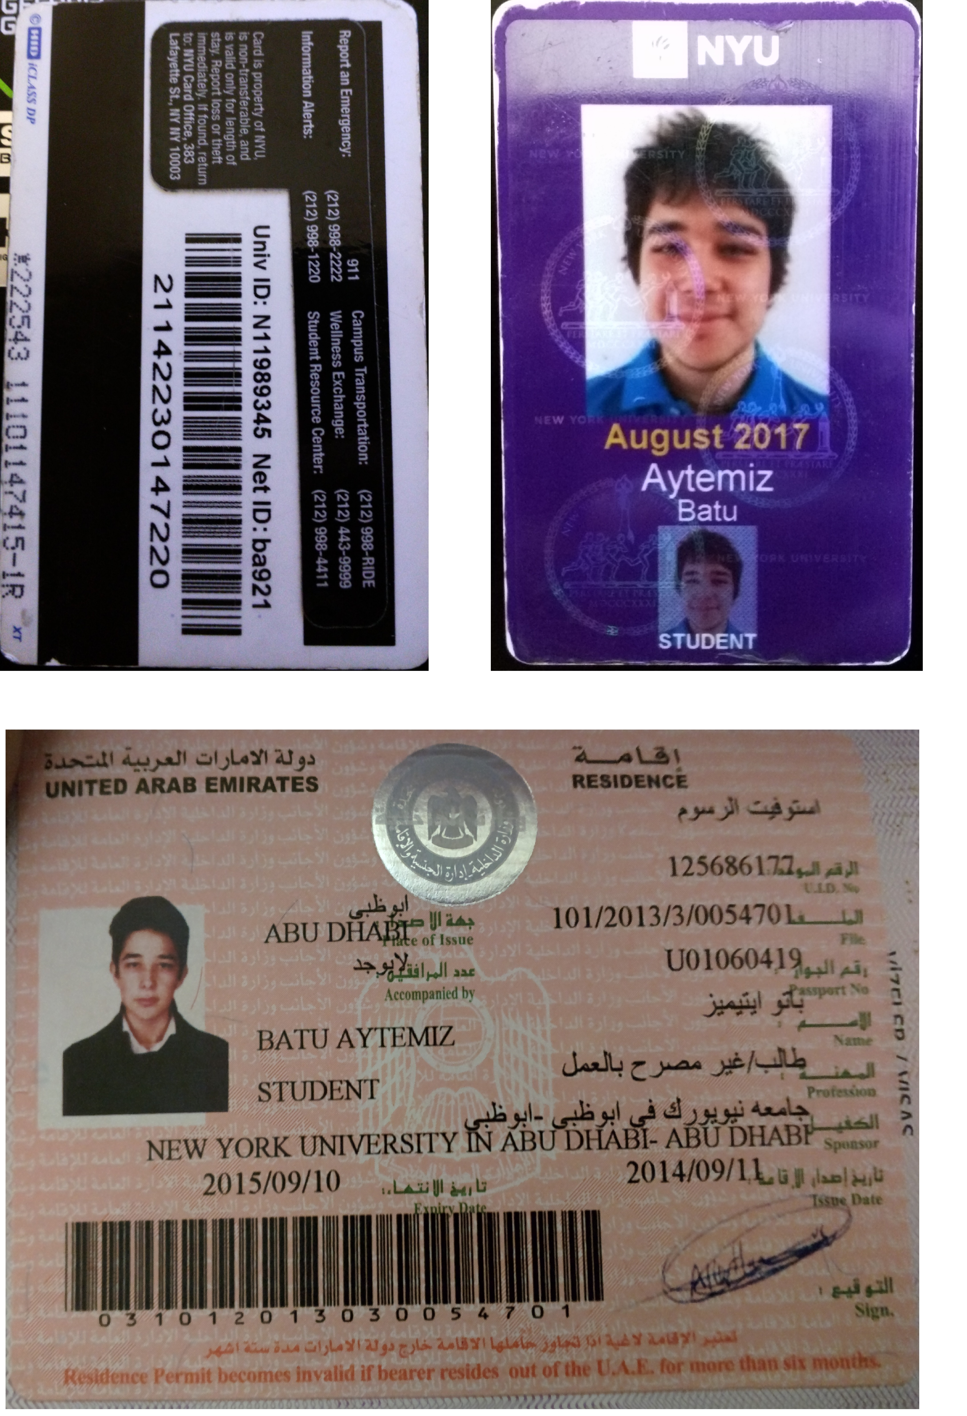

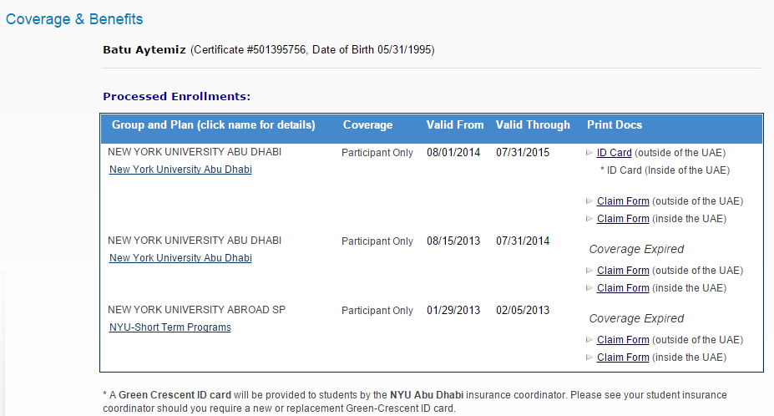

The list of past insurances to show that it will be revalidated for the dates of travel.

Notes

The applicant is a student of New York University Abu Dhabi. However he had been in New York studying in New York University for study away purposes for the 2015 Spring semester and will be studying in New York for Fall 2015 semester.

The applicant is invited his Aunt, Demet Anıl. The proof of this blood relation can be found in two steps. Fatma Fulya Aytemiz is the mother of the applicant (Batu Aytemiz) and Demet Anıl is the sister of Fulya Aytemiz.